RVI – Software Over The Air

Demo Script

Table of Contents

1. Change History 3

2. Contacts 3

3. Introduction 4

4. Demonstration 4

4.1 Show existing Audio Settings version 4

4.2 Select new audio settings package 4

4.3 Queue audio manager package 7

4.4 Confirm in-vehicle package notification 7

4.5 Wait for progress bar to complete 8

4.6 Acknowledge confirmation dialog 9

4.7 Display the new Audio Settings version 9

4.8 Display the DLNA Media Player 10

4.9 Reporting module in Backoffice 12

5. Demonstration reset 14

5.1 Select old version of audio settings 14

5.2 Queue old version of audio settings 15

5.3 Confirm installation of audio settings 15

5.4 Verify install of old version of audio settings 15

# Change History

|  |  |  |  |
| --- | --- | --- | --- |
| **Date** | **Author** | **Version** | **Changes** |
| 14/10/13 | M Feuer | 0.10 | Created |
| 14/10/17 | B Harmon | 2.1 | Edited, added screenshots |
|  |  |  |  |
|  |  |  |  |

# Contacts

Please address all queries to:

Author

Magnus Feuer [mfeuer@jaguarlandrover.com](mailto:xxxxxxxxx@jaguarlandrover.com)

Manager

Forrest Graham [fgraham@jaguarlandrover.com](mailto:fgraham@jaguarlandrover.com)

The answers will then be provided as quickly as possible, and any clarifications thought necessary distributed to all interested parties.

# Introduction

This demo script shall provide support during the SOTA demo that will be showing the Arynga, JLR, and AGL SOTA PoC at the 5th GENIVI CES Showcase demonstration Jan 6-9, 2015.

# Demonstration

## Show existing Audio Settings version

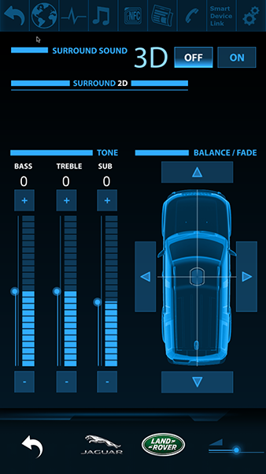

Audio Settings Screen

Highlight the lacking functionality in Audio Settings. There shall be no options for 2D sound prior to the SOTA update/upgrade.

“Notice the current state before the update. The Off button position shall be displayed by default, and there are no 2D or Stereo options.”

Once the Audio Settings page has been demonstrated, tap the upper return arrow to display the Home Screen.

“The Audio Settings screen enables the user to adjust the options available for playing media on the IVI by providing control for the vehicle’s sound system.”

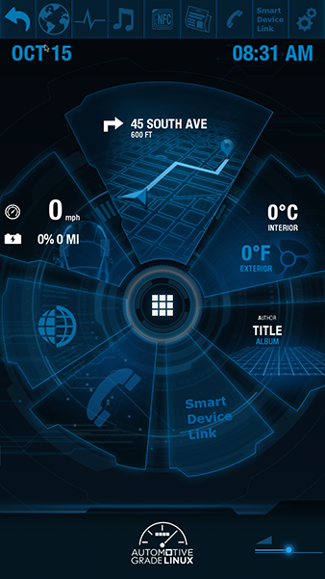

Home Screen

“A user may be viewing any app at the time that the JLR RSU is contacted by the IVI RSU when an update is available and downloaded. In this case, the IVI is displaying the Home Screen.”

## Select new audio settings package

Show how to create a new Release Package to update the Home Screen on the IVI.

The Backoffice application allows for fully automated management of software updates on vehicles.

**NOTE:** Base version should be present in back office system at demo start.

The application has an intuitive interface for users. A user might create a new software update for particular car model by selecting the RP MANAGER Module from menu on the left side.

The URL to SyncPortal is as follows: **http://arynga.eu:15801**

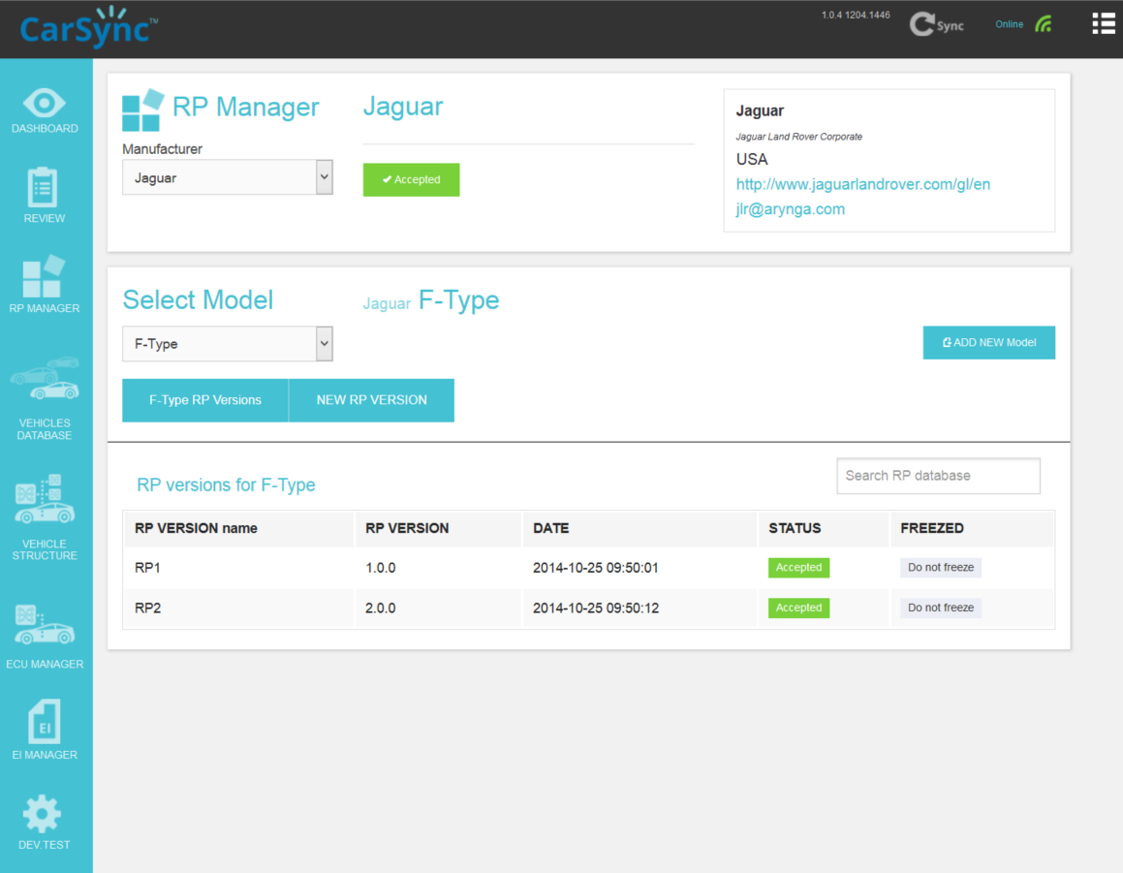

Rp Versions List Screen

Next **Manufacturer** and **Vehicle Model** must be selected from dropdown select list.

By default list of already defined **RP VERSIONS** should be displayed.

In order to create a NEW Release Package Version user clicks **"NEW RP VERSION"** button.

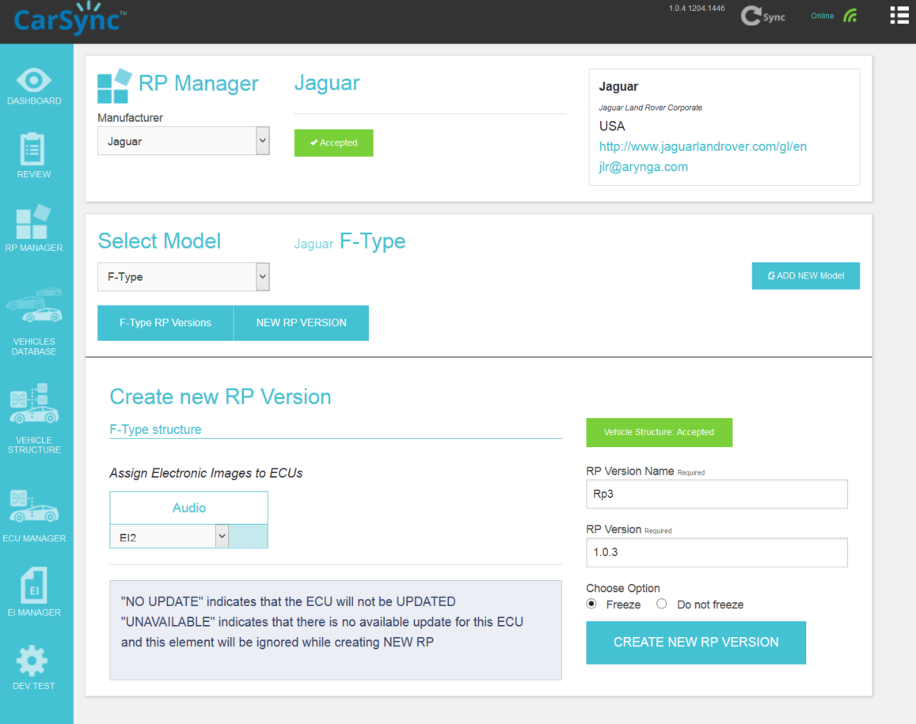

Creating New RP Version

**VEHICLE SCHEMA** should appear allowing to create a new Release Package.

To **CREATE NEW RP VERSION** select Electronic Image Version for ECU's in the schema.

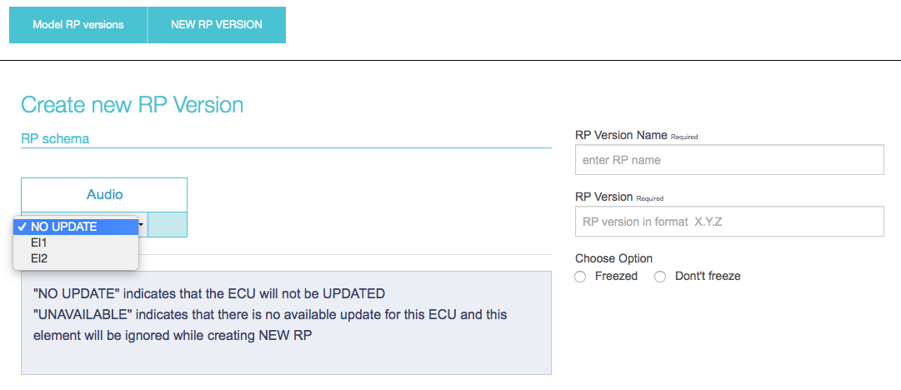

Selecting The Schema For New RP Version

Specify the name for the **RP VERSION** andassign a **RP VERSION**. In both fields unique values for the current version and name have to be provided. Note that the **RP Version** has to be higher than any numbers used for the previous versions (they can be checked by clicking “<***model>*** **RP Versions**” button).

Then select one of the “Freeze/Do not freeze” option. “Freeze” indicates that the version that is being currently added will necessarily be installed by a requesting car even though a newer version could be available at that time. In case when “do not freeze” option is set, the currently added version installation might be skipped if there would be a newer version available at the time.

Finally user must click the **CREATE NEW RP VERSION** button.

The newly created **RP VERSION** must be first reviewed, before sending a notification about new software update to vehicles.

The review is done by clicking the **Request Review** button.

## Queue audio manager package

The new **RP VERSION** will be sent to Tizen IVI from Arynga’s CarSync system just after a user performs synchronization with the Vehicle Backend System.

A user must perform the synchronization operation by clicking the **Sync** icon on the top right menu.

The Sync Module shows the information’s about CarSync Objects pending for synchronization with the VBS server.

To trigger the Sync action, click on the **"Sync data"** button and later the "Start VBS Sync".

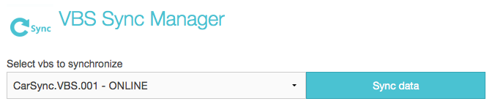

The Synchronization Manager

The synchronization status should be visible after few seconds in the VBS Synchronization logs.

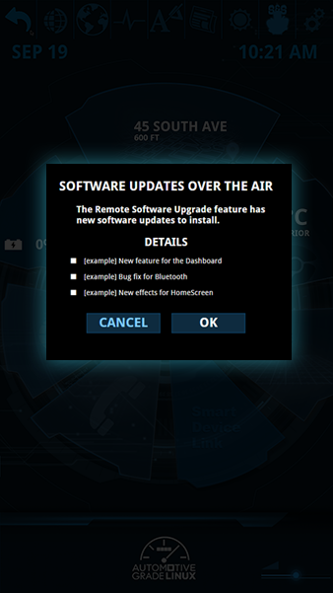

Home Screen with SOTA update modal

After the synchronization is completed a notification is sent to the vehicle about a new software update.

## Confirm in-vehicle package notification

“The IVI RSU displays notification of software package update or upgrade details on the IVI screen with a modal overlay. The user may cancel and do the update at a later time, or do the update now.”

Tap the ‘OK’ button.

“The RSU clears the screen of notification and starts the installation.”

## Wait for progress bar to complete

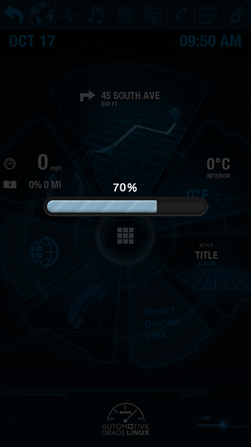

Home Screen with SOTA progress bar

When the progress bar has completed, indication shall be displayed on the screen.

Take a moment to highlight JLR achievements in regard to open source rapid application development…

## Acknowledge confirmation dialog

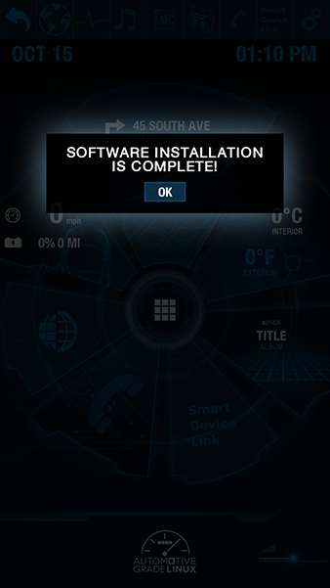

Home Screen with SOTA confirmation modal

Click the OK button on the modal, as viewed to the right.

The modal and overlay shall disappear.

Visit Audio Settings once again by tapping the Audio Settings icon located in the top bar, or tap the center APP grid icon to pull up the list of apps, and then select the Audio Settings icon.

## Display the new Audio Settings version

Highlight the new functionality by using the HMI and playing an MP3 audio track via the F-type sound system. “Notice the difference between the previous state and the updated state.”

The OFF button position shall be displayed by default. These are the 2D and STEREO options.

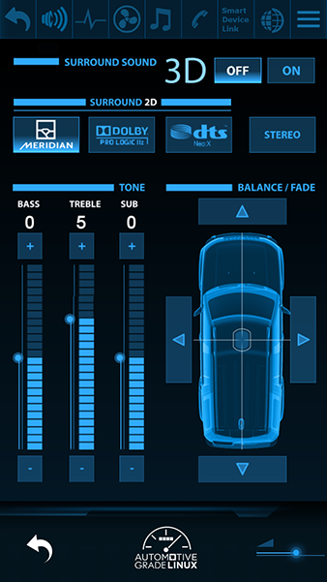

Audio Settings Screen

## Display the DLNA Media Player

Use DLNA Media Player to select an audio track that the IVI can play in the F-Type.

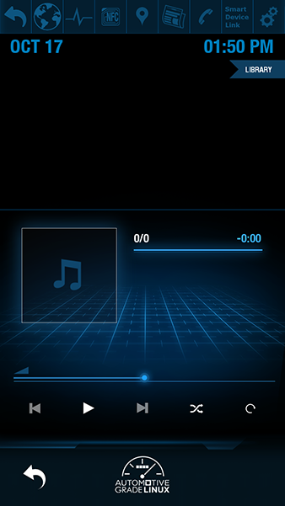

DLNA Media Player Screen

Tap the DLNA Media Player icon located in the top bar, or use the app screen. The Media Player icon looks like an eighth note.

“DLNA Media Player allows a user to play back audio and video content from local sources via the tizen.content API and remote DLNA content via IVI WRT Mediaserver API.”

Once the Media Player screen is being displayed, tap the flag-shaped Library button at the top right under the time.

“Audio content to be played can be selected from the Multimedia library component. Playback is controlled by the AudioPlayer component. Upon launching the app, the user can access the library and view thumbnails.”

“Choose your media and the library closes. Then the application displays a thumbnail and details about the track while playing it.”

Tap the MUSIC selection, then ALLChoose a music track to play.

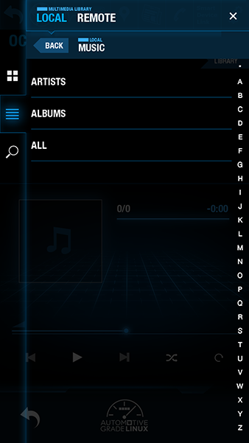

DLNA Media Player Screen

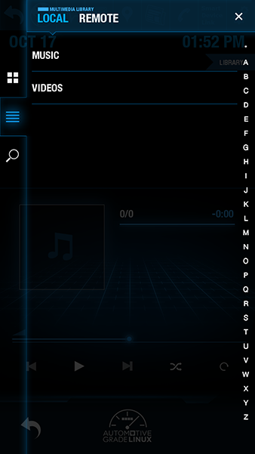

DLNA Media Player Screen

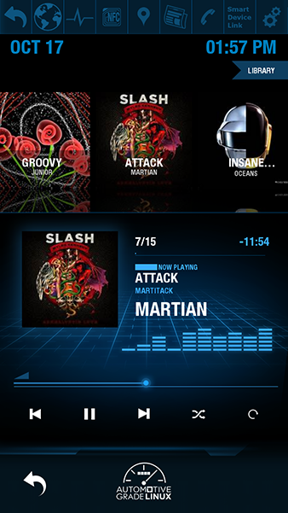

DLNA Media Player Screen

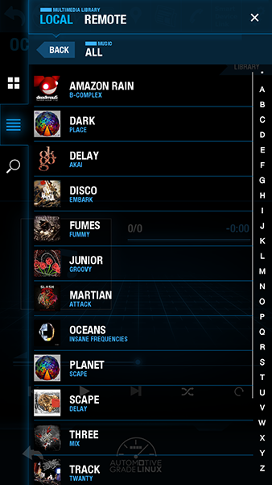

DLNA Media Player Screen

Having chosen something from ALL, several tracks shall display, giving the option to continue listening for a bit.

The volume may be adjusted in this app.



Audio Settings Screen

Return to Audio Settings.

“Audio Settings is now enabled to make adjustments to the balance, fade, bass, treble, and various options for the type of Dolby/surround sound in 2D.”

## Reporting module in Backoffice

The Backoffice systems reporting provides complete analytics dashboards for data analytics and visualization. The dashboards allows user to see the current statics about vehicles and RP versions being used.

The Dashboards can be reached from the menu on the left side.

The first Dashboard presents the total number of vehicles registered as well as the number of vehicles that has made a successfully reported to the IVS.

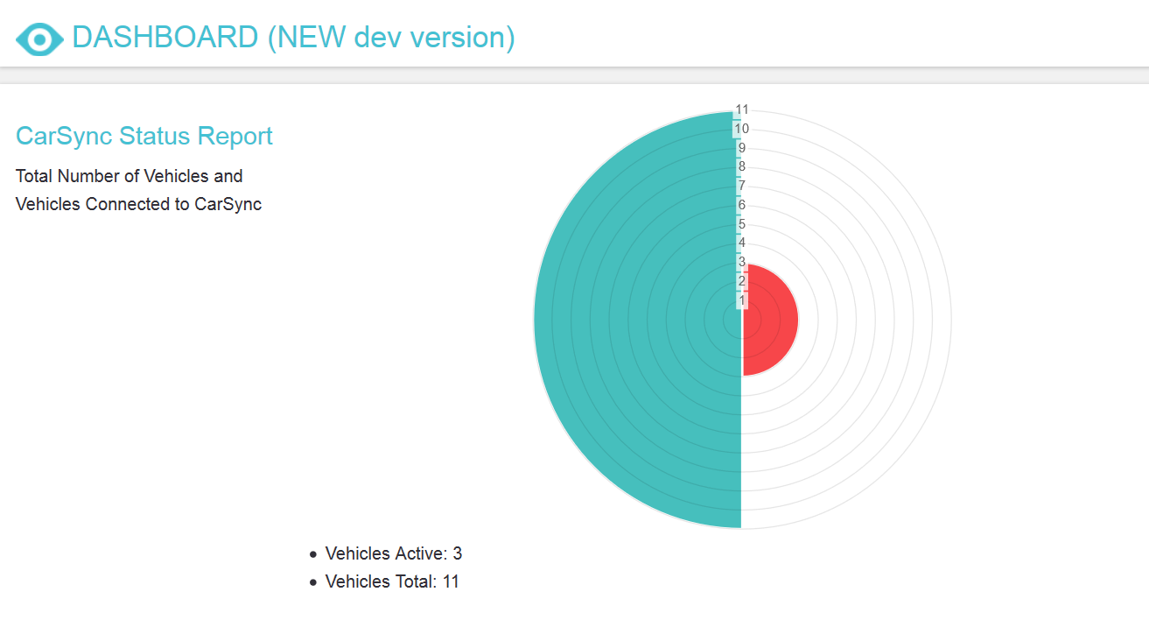

Dashboard with statistics about connected vehicles

The other graphs present report regarding updates and installed versions of software on vehicles.

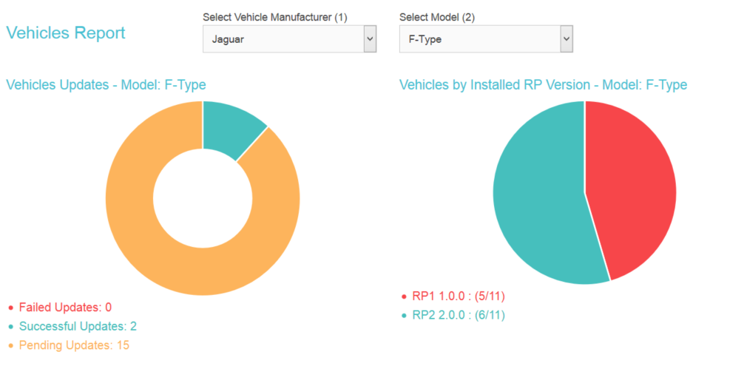

Dashboard with statistics about RP versions per model

# Demonstration reset

**NOTE:***In case of questions that concern resetting the* Backoffice *system to its initial state*

*prior to demo, contact Jan Murlewski,*

*mobile : +48 605 075 859,*

*email: jan.murlewski@arynga.com.*

## Select old version of audio settings

The Home Screen can be reverted to original version by creating a new RP Version with the old version of the Electronic Image.

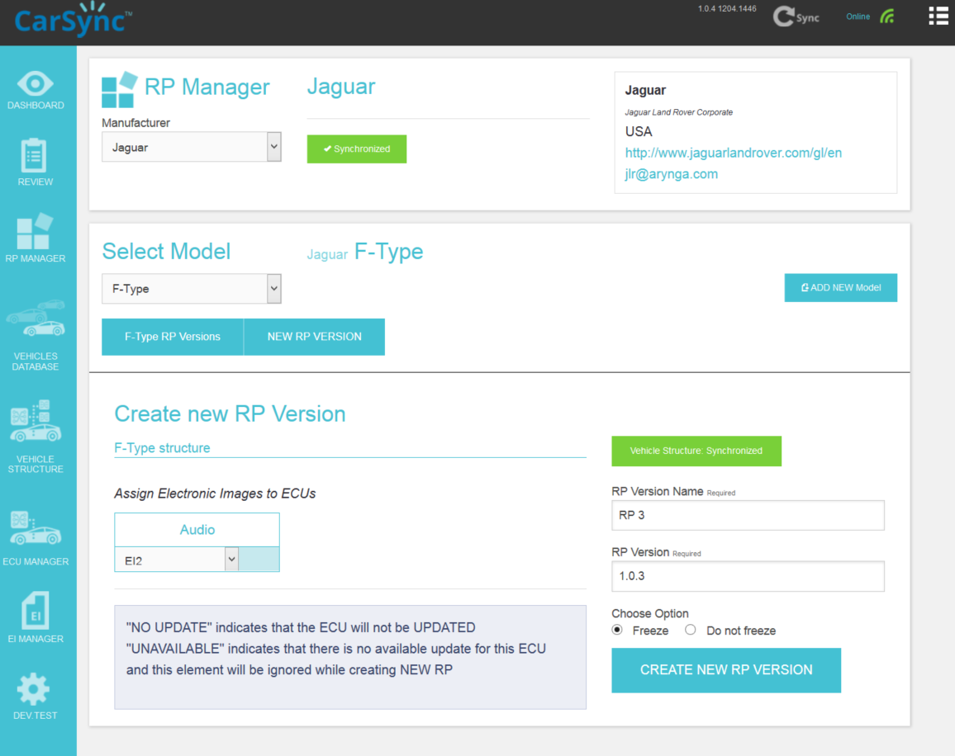

Creating a New RP With Old Version Of Audio Settings

Select RP MANAGER Module from menu on the left side.

Select existing **Manufacturer** from dropdown select list.

Select existing **Vehicle Model** from dropdown select list.

Create a NEW Release Package Version click **"NEW RP VERSION"** button.

**VEHICLE SCHEMA** should appear allowing to create a new Release Package.

Select Electronic Image Version 1 for the ECU in the schema.

Click **CREATE NEW RP VERSION** button.

After this operation list of existing **RP VERSIONS** should appear.

Click **Request Review** button to REQUEST REVIEW and ACCEPTANCE for Newly created RP VERSION.

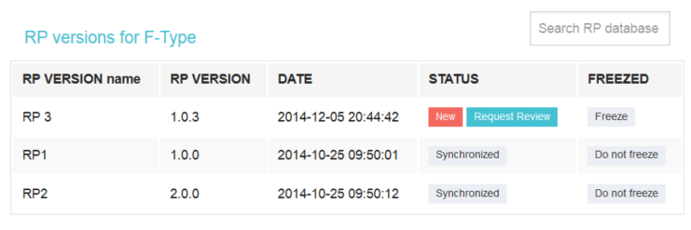

Making A Review Of New RP Version

## Queue old version of audio settings

The next step is to synchronize the newly created RP Version with the VBS, so the vehicle will get notification about a pending update. The scheduled update will install the old version of audio settings.

To trigger Sync action click on the **"Sync data"** button on the top of the page.

Click the "Start VBS Sync" button to Synchronize data with VBS.

Sync STATUS should be changed to "running" as shown below.

The synchronization status should be visible after few seconds in the VBS Synchronization logs.

After the synchronization a notification is sent to the vehicle about the new update.

## Confirm installation of audio settings

“The IVI RSU displays notification of software package update or upgrade details on the IVI screen with a modal overlay. The user may cancel and do the update at a later time, or do the update now.”

Tap the ‘OK’ button.

“The RSU clears the screen of notification and starts the installation.”

## Verify install of old version of audio settings

Launch audio settings and verify that 3D buttons are gone

I shall fill in the details here when we know more of the progress of back-end to front-end components. Once we are able to connect the JLR RSU to the IVI RSU and have the JLR RSU send an update, we can figure out how to script sending the message to the IVI to run the updates for the demo, and then reset it. The Audio Settings will probably respond to the state of the HomeScreen in how it displays the elements that the update will display during the process, via CSS display properties.